Insight Idaho Federated AI Swarm

I am providing a quick recap of the recorded live demo meeting to demonstrate the capability of the POC for SCO’s Insight Federated AI Swarm. Refer to the document, “The_Idaho_Intelligence_Swarm.pdf” to see the structure of how a swarm is designed.
The purpose is to demonstrate the ability to ask a question and get real-time results using AI. The entire POC is self-contained meaning that none of this is using any Frontier platforms (ChatGPT, Anthropic, Grok, etc.). *Note: the data is based on a small fake data set.

Question: How many people are in IDOC?
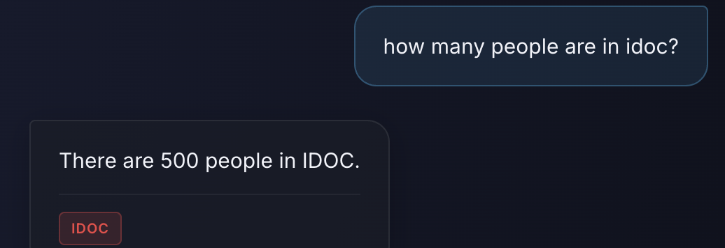

Question: How many people in IDOC and IDJC have records related to robbery?
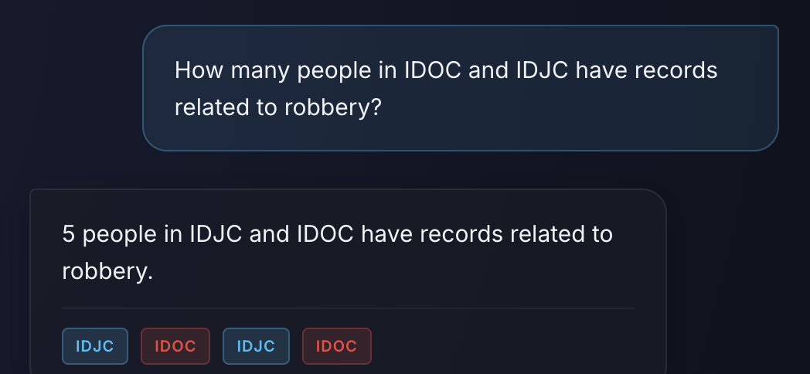

Question: How many people in IDOC are in for murder? List the different types.
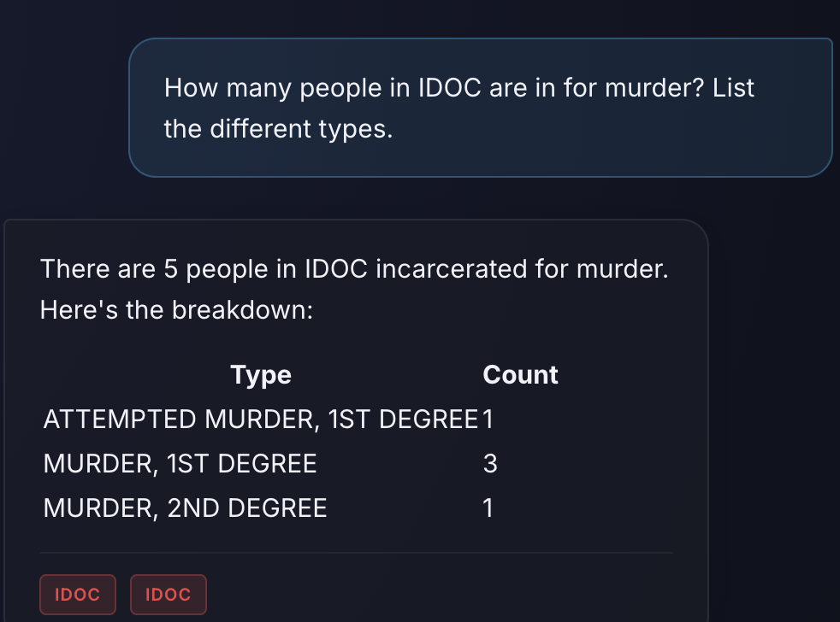

Question: Count the number of people in for drug-related crimes in IDOC.
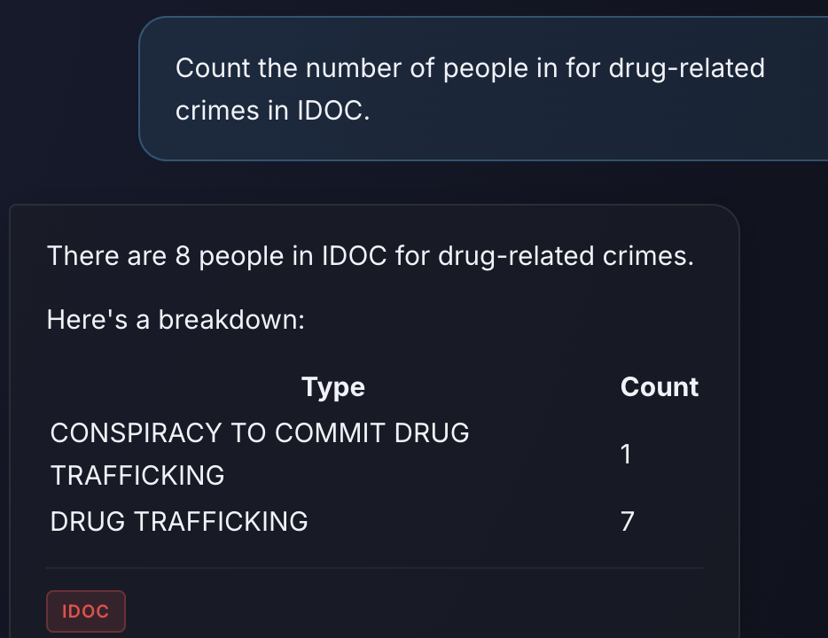

Question: Give a list of the top 10 IDJC individuals with the most offenses
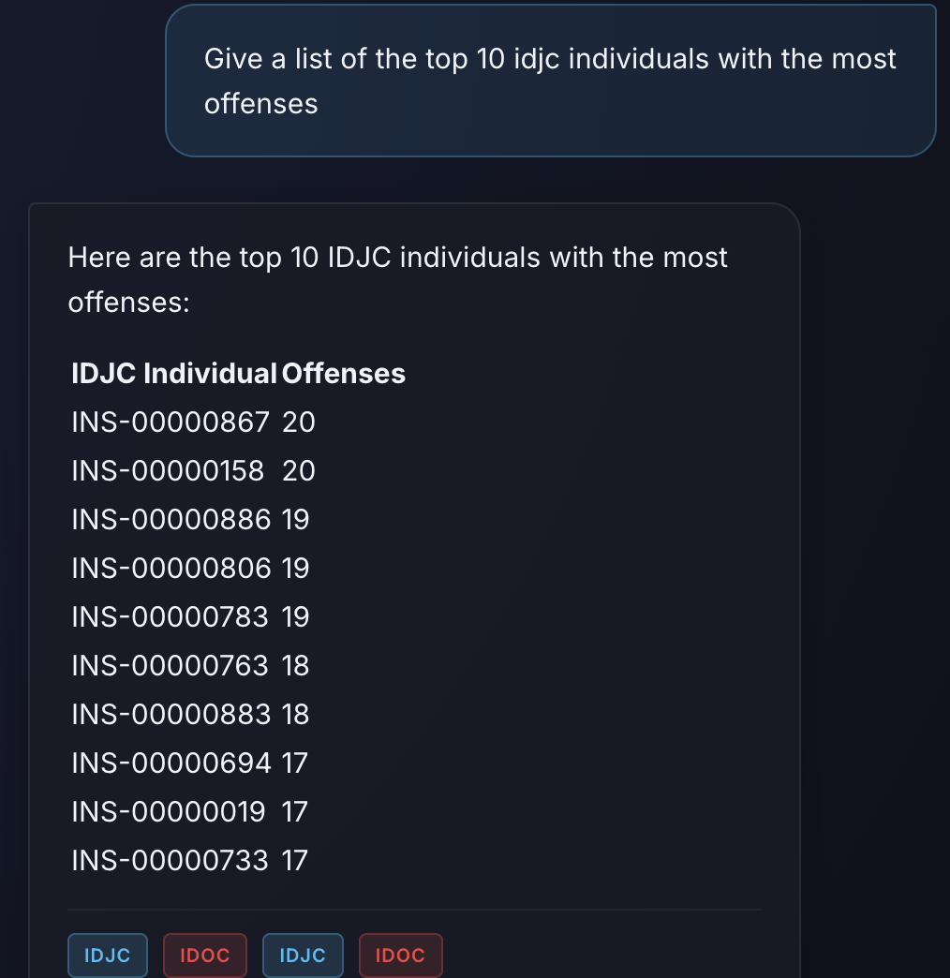
Shows the list of Insight IDs and offense count. This demonstrates that you can specify a specific number of returned records.

Question: Show me a breakdown of all theft-related offenses in the juvenile records (IDJC).
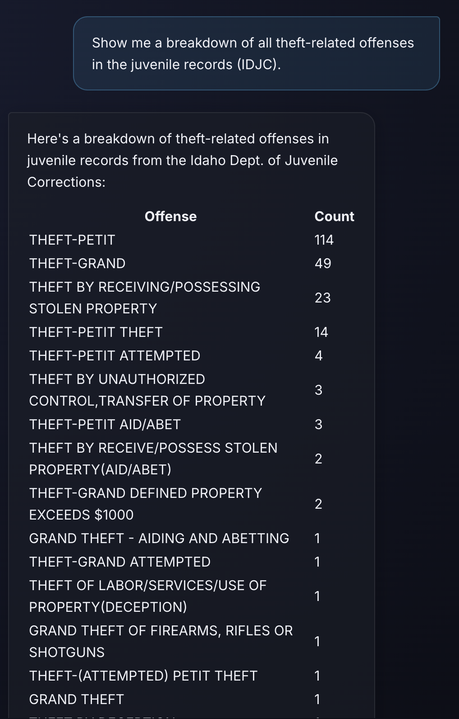

Question: Give me a list of assault charges and their counts from the juvenile system.
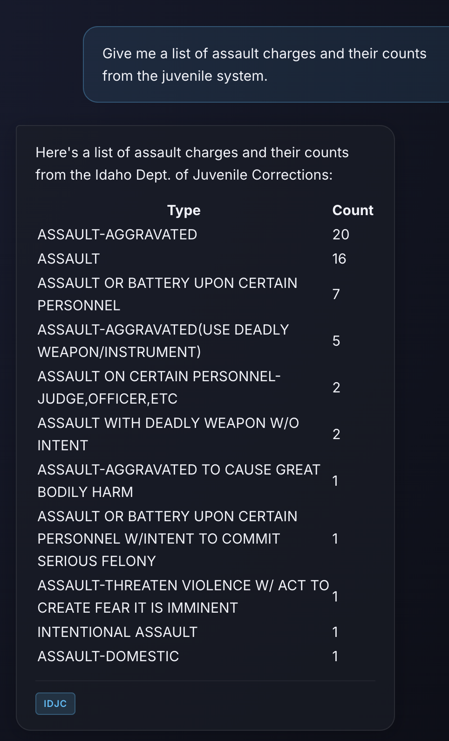
Notice the question does not specify IDJC. It asks about the juvenile system.

